June 1, 2002

Scotts Performance
2625 Honolulu Avenue
Montrose, CA
91020

Attn: Scott of Scotts Performance Products:
Cc: Steve Zollinger

After the recent purchase and attempted installation of a Scotts Damper and bracket kit for my 2001 Suzuki SV650s, I have discovered what I believe to be a manufacturing defect, installation instruction flaw, and severe safety hazard; which is inconsistent with my previous experience in the quality of Scotts Performance products.

Problem:

The installation instructions provided for my 2001 SV650s are used for both S model and non S model bikes, as indicated by the boldfaced underlined header of the provided instructions which states:

INSTALLATION INSTRUCTIONS FOR: SUZUKI SV 650 1999-2002 and SVs 2001-02 using clip on bars
Additionally, it appears as if the same hex nut / TC mount combination is used for both model motorcycles. It is important to note the differences in these two motorcycles which causes the current SVs parts to not only function improperly, but present a safety hazard as well

Background:

My racing family of motorcycle enthusiasts, 3 of us have Mechanical Engineering degrees, believe that the Scotts damper is a superior motorcycle product. Our dedication to the quality in construction and performance of the Scotts Damper is demonstrated upon inspection of our garage; shown below are 3 Scotts Dampers, installed on a gsxr750, an r6, and a race sv650.
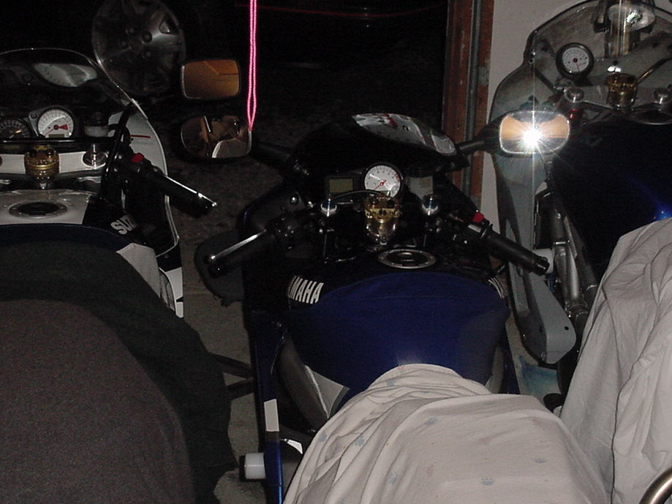

I was attempting to install our 4th Scotts Damper on my street SVs when I encountered this mounting problem. I was able to compare the fit of the mounting bracket on my SVs to that of the race SV, allowing me to identify and present a possible solution to the apparent problem.

Cause:

The mounting bracket supplied for the S model and non S model bikes appears to be the same. However, the top triple tree of the S model bike is different than that of the non S model bike; resulting in an ineffective and unsafe mount if the installation instructions are followed. Note the difference in triple clamps below:

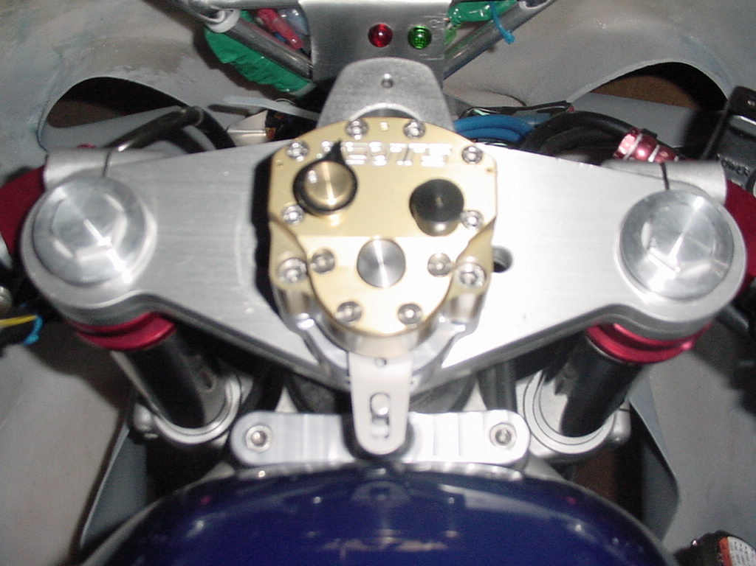
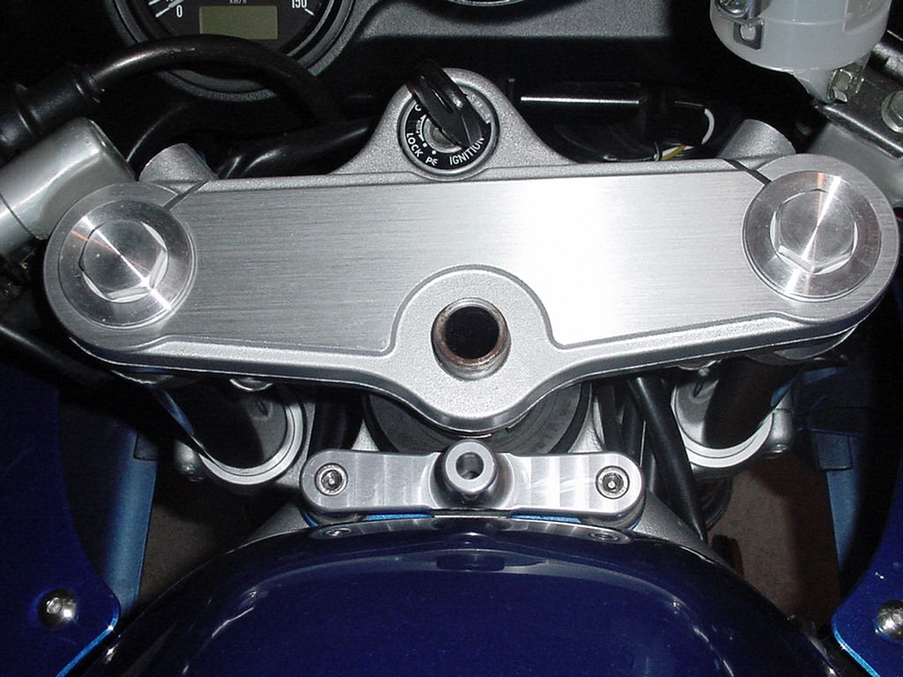
race SV650 w/ clip on bars
street SV650s, stock

The top surface of the SV650 top triple tree is a flat, uniformly machined surface; while the top surface of the top triple tree of the SV650s has both a cast surface, and a machine finished surface which sits approximately 1.5mm above the cast surface. Because this surface of the SV650s model is not uniform, the hex nut / TC mount combination will not install properly on this motorcycle. The hex nut and TC mount are designed to sit flush on a uniform surface, as seen on the SV650. The difference in height between the two surfaces of the S model triple clamp causes the TC mount to sit effectively higher than intended, resulting in an inferior mount.

Supporting Evidence:

The evidence of inferiority of the mount is only noticeable to a meticulous eye. The view of an installed TC mount is shown below:

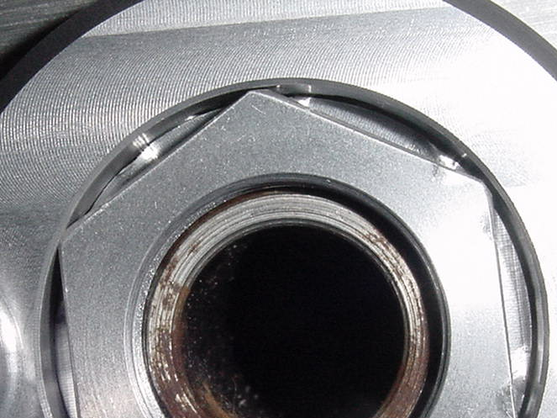

The dimpling seen around the perimeter of the base of the hex nut is attributed to tightened setscrews which sat too high. The setscrews struck the hex nut above the intended groove, on the flat surface in between the groove and the hex portion of the nut; this is better demonstrated by the witness marks shown on the nut below:
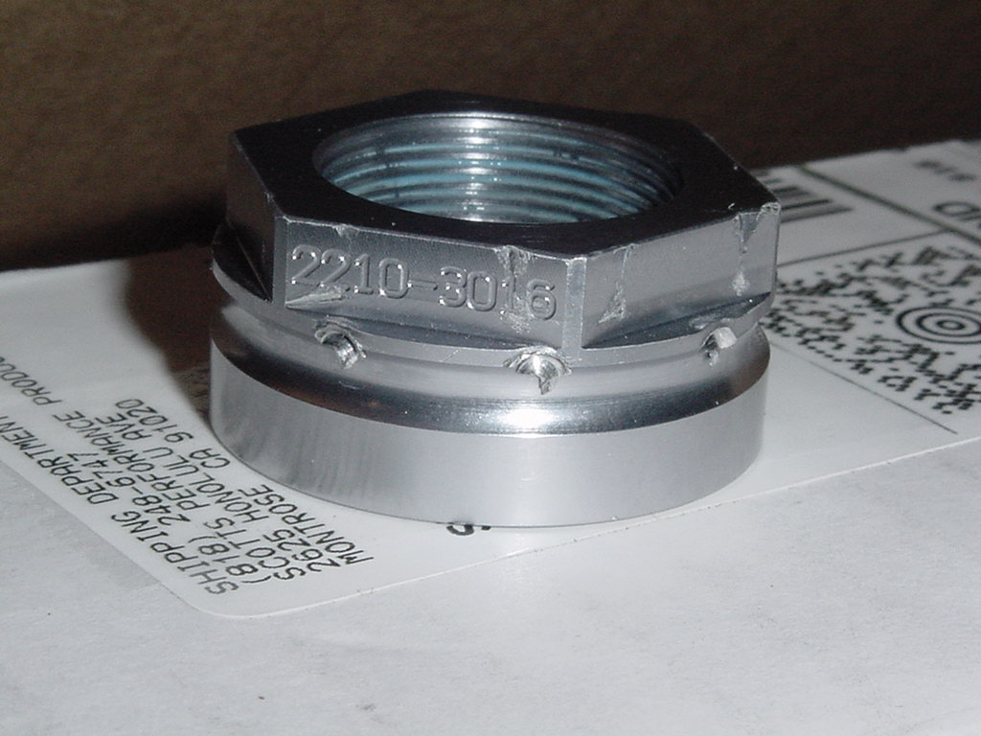
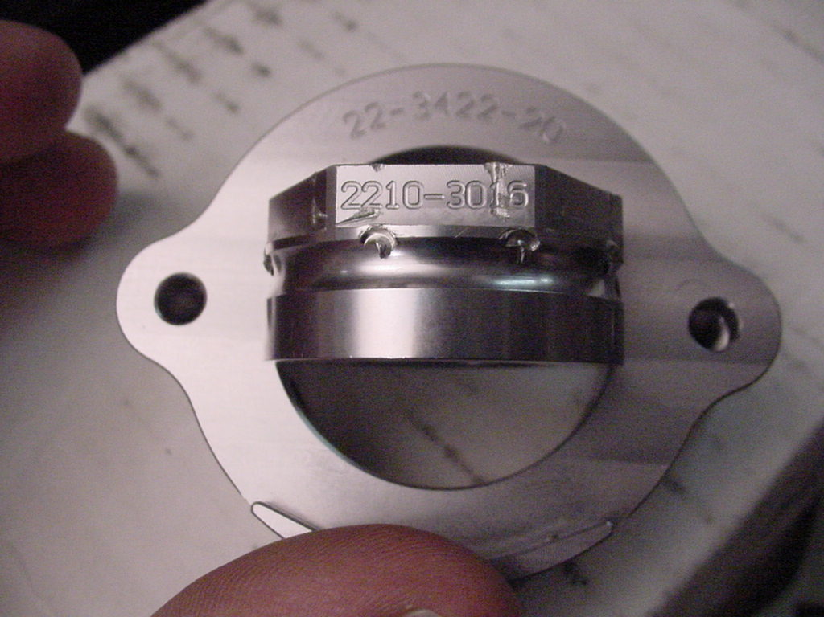

Note the part numbers of the hex nut and TC mount shown in the picture to the right. These numbers were verified with the staff at Scotts Performance and confirmed to be the correct part for a 2001 SV650s.

Additionally, the lower lip of the TC mount does not conform to the shape of the upper triple clamp of the SVs. The machined lip is apparently too shallow, and does not cover enough of the radius of the TC mount to prevent rotation once the part is installed as shown below:

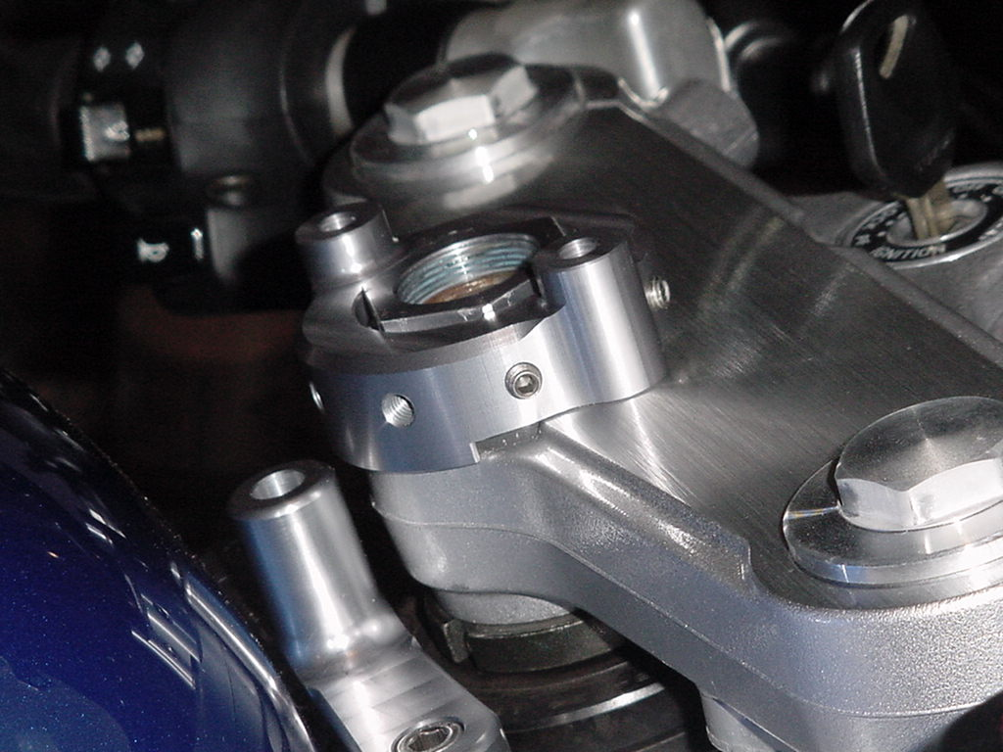
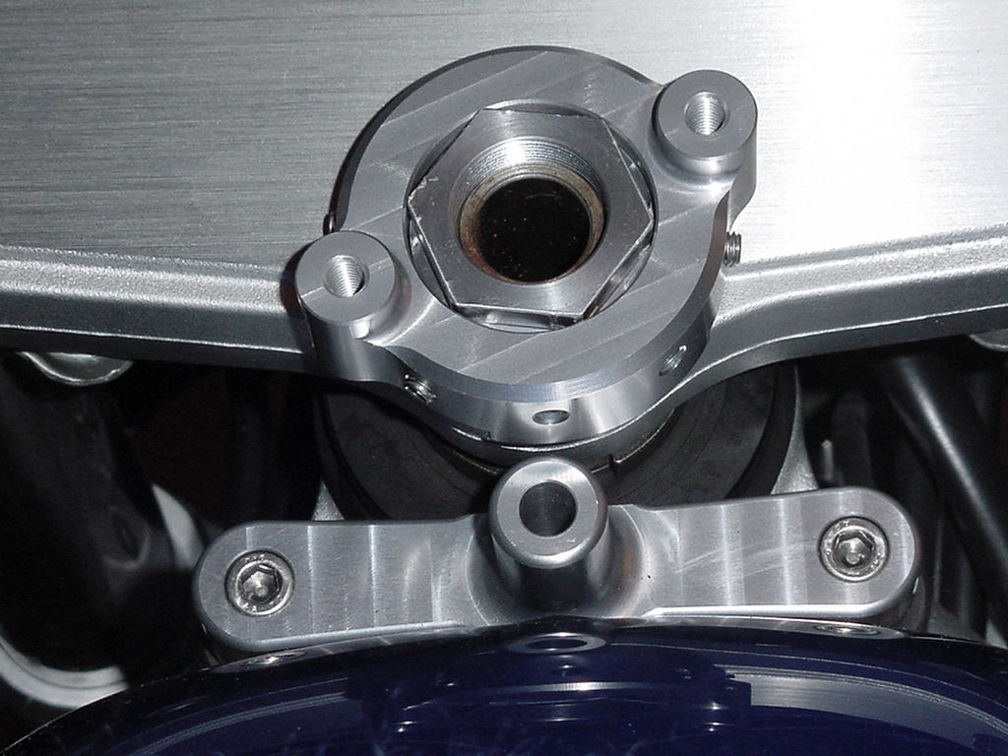
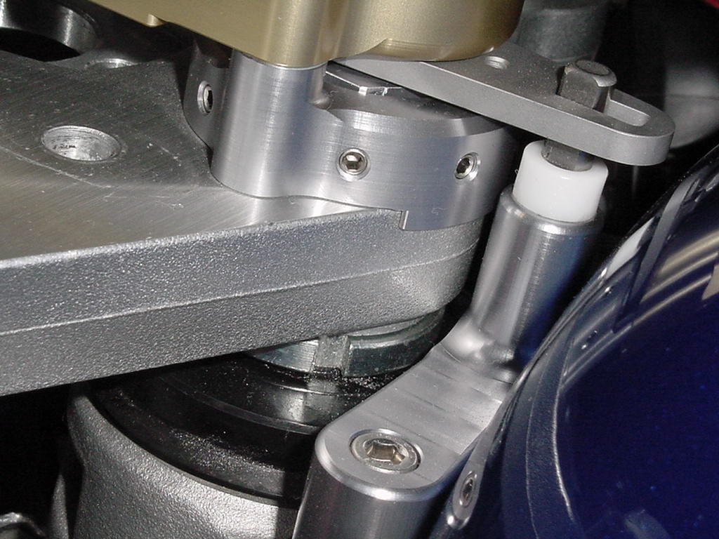
The same part installed on the non S model fits the bike nicely; the lip is the correct height and covers enough radius to prevent rotation in the event of setscrew failure:

Possible Solution:

The same parts were re-installed on the S model bike with the OEM washer on the hex nut, against the installation instructions. The setscrews appeared to better match the machined groove of the hex nut, as seen by the second set of witness marks on the same hex nut:
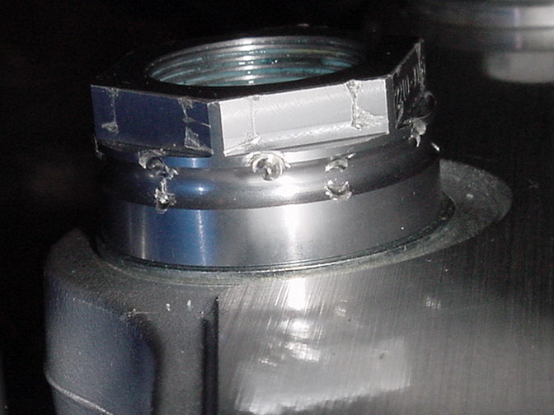

When the washer is used the top of the hex nut sits just above the top of the TC mount, which is consistent with the other 3 installed Scots Dampers in the garage:

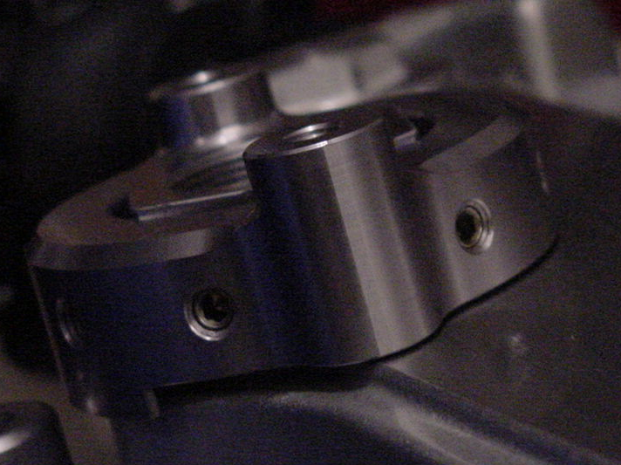

Although this may be an apparent solution, it is still obvious that the kit is not intended to be used as such. The TC mount is not sucked down by the setscrews to be flush with the triple clamp (as seen above), deviating from the consistency of the other 3 installed Scotts Dampers in the garage. Shown below is the flush fit as seen on our SV650 race bike:

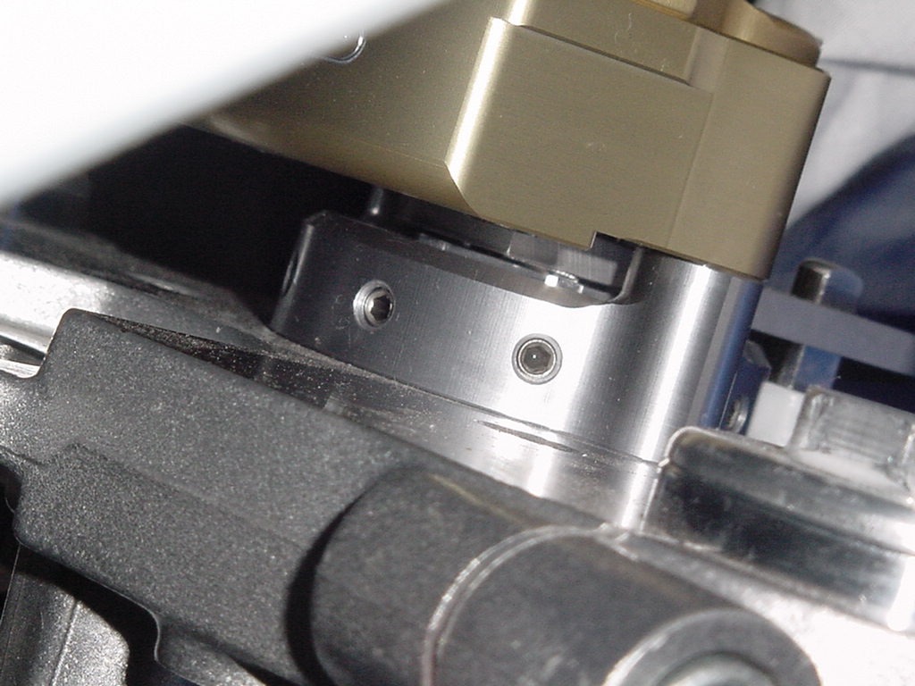

Furthermore, if the mounting bracket is to be used with the OEM washer, the tower pin will not protrude all the way through the lever arm of the bracket. It is necessary to slide the opaque white nylon collar further down the tower pin to allow for a greater height above the collar. This will allow the tower pin to protrude through the lever arm, and appear consistent with the 3 other observed tower pins. Scotts Performance staff has informed me that the minimum height of the tower pin in the lower mount is 20mm; this minimum was not violated as the current setup has 23mm of tower pin inside the lower mount.

Conclusion:

Based on the observations I have made, actively comparing Scotts Damper mounting brackets on both S model and non S model bikes, it is clear that the supplied mounting bracket is not intended for use with the SV650s. I find this hard to believe considering that the installation instructions include pictures of the same triple clamp of my S model bike. If the confirmed parts are used and the installation instructions are followed, the resulting mount is neither functional nor safe. Being that this predicament is highly inconsistent with my previous experience with Scotts Dampers, I would hope that Scotts Performance products recognize and investigate this problem immediately. Considering that over 170 kits have been sold for this model motorcycle (quoted by a Scotts Performance employee), and assuming that all kits included the same parts and installation instructions, the result of which is likely to be 170 opportunities for litigation as a result 170 improperly installed and unsafe Scotts Dampers on the road.

Much to my disappointment, my experiences with the Scotts Performance staff have not been entirely positive. I had a difficult time trying to explain the problems I experienced to a Scotts Performance staff member, and was accused of being wrong, due to the fact that all parts are computer numerically machined. I am among 2 other Mechanical Engineers in house; we used precision measurement devices to spec the critical dimensions of the hex nut, and ultimately concluded that the part was simply wrong. After discovering that both the part and instructions for my particular motorcycle were wrong, I requested a new hex nut from Scotts Performance. While requesting the replacement nut for my Scotts installation be over nighted to avoid further inconvenience I was confront with a disappointingly unprofessional, inpatient and unreasonable Scotts staff member.

I have invested my personal time and effort, as well as almost 1 hour in telephone charges working in conjunction with the Scotts Performance staff trying to remedy your error. I feel as though Scotts products are of the highest quality, and the application for this particular model motorcycle was simply not approached with the same diligence as the other three I have installed. I was most easily able to reach an ultimate conclusion to a possible solution for this model bike based on the comparison of the other 3 installed Scotts Dampers in my garage, one of which was on a race SV650. I cant imagine that this problem has persisted for the 2 years that this motorcycle has been in production, nor can I imagine when this problem would have been otherwise recognized, had the Scotts Damper not landed in our hands.

I feel as though my efforts and costs incurred while working jointly with Scotts Performance to remedy a potentially catastrophic problem should be rewarded. I would like to ask for a replacement hex nut and TC mount as soon as Scotts produces one that fits the SV 650s appropriately. Surely this would be a minimal cost to Scotts Performance to retain a racing customer base and strong reputation for product and service.

I look forward to your reply or call to discuss further if you so desire.

