Page 1&2 : Free geometry changes

Page 3 : Free advice on tyres, my reasons.

Page 4&5 : Nearly free suspension tweaks

Sharpen up your geometry
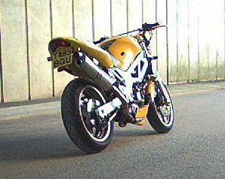

The SV650 handles very well, one of the best, this we all know. But some people like it more radical , quicker to respond, and with more ‘feel’ for what is going on between the front tyre and the road.
And some just like to tinker.
Tyres make a difference (see separate article) but some useful alterations can be completely free. Almost as easy as adjusting the rear ride height, a few minutes with two standard tools, a penny and a zip-tie might make ‘near perfection’ even better...

“If you feel like you’re in control your not going fast enough” (Mario Andretti)
Tight circuits are all about quick turns and many racers like a steering geometry set up that is virtually unstable, hence their wobbles on the straights. Sports Bikes like the Fireblade, TL1000 and others are set up so sharp that tankslappers are possible if ridden to extremes. But they are pure sports bikes and not for dweebs. If you are likely to panic whenever your bars start shaking side to side you should perhaps go for something more sedate. Like a Firestorm. Or a Harley! If you want razor sharp steering your bike has to be less steady.

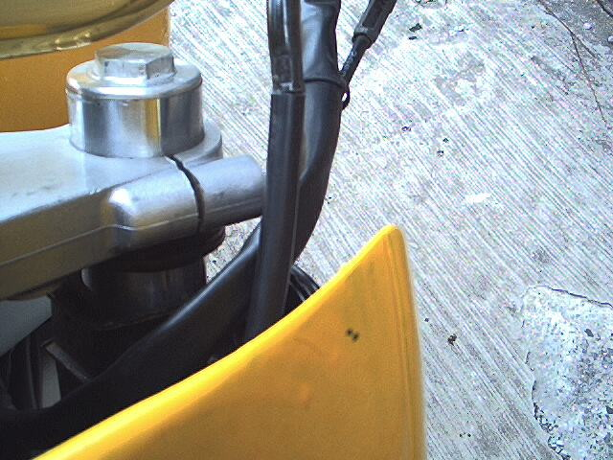
<-
<-
20 mm of
extra leg

“Why bother?” (My wife, Constantly.)
Every time you use the front brake your forks compress and the head-angle sharpens (noticed the ‘feel‘ increase and the steering quicken?). A little of this ‘compression’ can be retained by dropping the bike through the yolks a little. 25mm is roughly one degree less head-angle but may see something bottom-out or break. Try 20mm, for free.

“If in doubt leave it out “( My Star-rider instructor, 22 years ago.)
He was talking about overtaking, but it applies equally well to the art of motorcycle maintenance. Everyone knows what a spanner does, but unless you are confident about the parts that your bolts hold together leave them torqued up. You are hereby warned and I am hereby absolved of all responsibility. (there, Mr LegalBeagle, happy now?)
On a paddock stand, or with a mate holding it upright, loosen but don’t remove the bottom yolk bolts, then loosen the top yolk Allen bolt until the fork can slide. Slip it up through the top yolk by 20mm of stanchion. A 1p coin makes a good measurement device! Torque down the fastenings, and then do the other leg. If a fork is seized in the yolk you may need to prize the split open with a wedge or large screwdriver but be careful on soft alloy. Twisting the leg should also ease it through. If its not fairly simple you aren’t doing something right.

“Are you finished, yet?” (Another of my wife’s favourite sayings.)

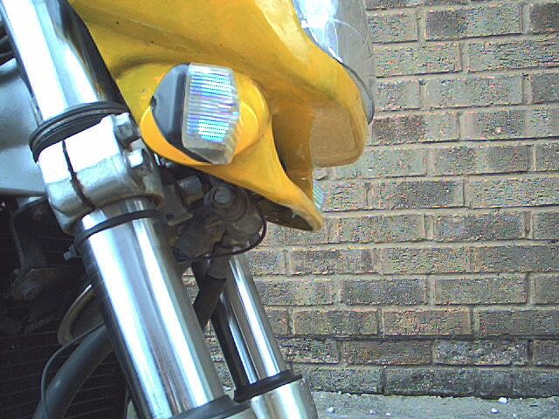
Still 10mm clear of the bottom yolk, despite hard braking over bumps
Not quite. A sensible precaution is to put a zip-tie around the fork leg just above the seals. It will be pushed up the leg while you ride and show the highest point the fork leg traveled to. Mine is still a good 10mm from danger and I have no marks on my fender extender or mudguard despite riding it hard. My springs are not even progressives. But as some bikes have less room under here it pays to keep an eye on it. If you want more damping look at my article on fork oil.

My arse! (Ricky Tomlinson)
The rear ride height is set to maximum. Its mostly for looks but this also tips the front forward a smidgeon. I like my high wide Renntec bars and I tend to sit right up to the tank gripping it with leather-clad knees. I struggle in jeans or waterproofs – no grip. Though the back end can get a bit light at times, even skipping out if you are harsh on the rear brake, I can feel every nuance from the front. It turns in quickly but doesn’t wibble about and when I’m back on the grippy neutral steering Metzlers I’ll be as happy as a pig in doo doo.
And just as uncatchable.

Tyred of advice?
There isn’t much more than a credit-card sized bit of rubber connecting any bike to the surface of the planet. The forces that you apply through that tiny patch are tremendous. One horse can sheer rubber from tarmac (and how many do you have, seventy?) Add centrifugal forces pushing you out in a corner, and bumps. How flexibile is your tyre? And the shape of it’s arc as it leans over. Did I forget to mention water sometimes gets between the rubber and stone? All this is happening less than an inch off the ground, regardless of what bike happens to be above it.
Oh, sorry, double all that, and add the complexity of two different tyres working against each other, unless you ride a unicycle, or wheelie everywhere!
Its no wonder then that tyres affect everything on a bike.

When I first got my SV650 it wore a Michelin front and Metzler rear in a mismatched mess. It dropped into slow turns like I was being pushed over. Accelerating hard over rumble strips it gave tankslappers so violent that I shouted at the thing to calm down. (Huh? ‘back off?’ Whats that?)
I’m sure as a pair the Michelins would be fine hoops, but pairing different manufacturers is a bad idea that is waiting to hurt. I fitted a Metzler ( a softer Mez3) to match the stock Mez4 rear and found religion. Later a Mez3 rear got eaten up pretty quick but was a great tyre to use. They are a neutral profile, U-shaped not V-shaped. They do what you want them to do progressively rather than tipping you off the crown onto the side. Crucially they hold their line if I brake cranked over. I never remember them slipping away either. They seemed not to need to warm up, or did so before I’d noticed. Utterly dependable. Can’t wait to put them back on.
After many miles of sheer abuse (pun intended), and a recommendation from SV riders, I put Bridgestone 010s on it. Personal taste, you may like ‘em, but I don’t. After the super-grippy Mez3 I suppose any tyre was going to feel less dependable but I find I am just waiting for these to break away from me. Braking when slow(ish) on a retail park the back end switched out like Naomi Campbell at the end of a catwalk. Looks great - but don’t fall over.
Every time I brake at the end of my road the back locks up, too cold to be counted on. It’ll be like a 20p piece before long. I’m glad I was taught to use loads of back brake in towns (diesel, dripping cars at junctions..) as to lose the front is scary.
Even well warmed up, and going fast into that sweeping bend onto the M56 from the M6 southbound the slightest bit of damp had the back end power-sliding out like I was rear-wheel steering it out of Druids into Hangar straight or something. But my name isn’t Rossi. I suppose these 010s lose it progressively, and with feedback. A bit like being let down, nicely, by someone with good manners. I prefer not to be let down at all.
A good burn out at Hoghton Sprint on the 25th April will take a few months off my 010, and from then on I’ll be a Metzler-man with this bike.

Oil change or head transplant required?

Suzuki aimed this bike at the masses and did a damn fine job of it at that. This middleweight is such a good all rounder the press struggle to find a niche for it and it gets a slightly naff tags like ‘best first big bike’, or worse, despite being quicker than many 600s. This led me to add a bit more testosterone to the looks as well as the set up. More on this another time. It pains me to say it this isn’t a puresports bike. If it had been given a razor sharp edge it wouldn’t have appealed to so many of us. The budget front end wasn’t meant to suit adrenaline junkies who like to feel every stone in the tarmac and find the edge of adhesion. But some tinkering is all you might need, not a gixer head transplant.

Early SVs didn’t have adjustable forks. If you want to play with suspension settings you can try swapping the forks for something else, or fitting parts from a later model. But a far cheaper alternative if you want a firmer ride could be to change the stock 10W oil for something a bit firmer. It’s messy and takes a good hour to do, or undo. But I tried it on mine and was happier with the feel I get from the front wheel. For less than twenty quid it was well worth it, and now I know what I’d like to spend my birthday money on. Some braided hoses.
I’d like some progressive springs but only later. When I can afford them. Perhaps Santa might be reading this? ( Mrs Pillion, Sweatheart? Read this again for me?)

If you haven’t been a good boy buy yourself a litre of 15W fork oil. I put 20W in mine and it’s a bit harsh. 15W was recommended to me but I’m one of those people who always thinks he can go one better. You know the type? The advice came from an SV650 forum item, a lass in Peterborough I think, anyway, my gratitude and apologies for not following your advice to the letter.

Want to have a go?
I used: Some clear tubing (from an old vacuum cleaner soap thing?) to siphon the old oil out, a plastic measuring jug (no, love, not the one I scramble your eggs in…honest) A litre of 15W fork oil, a tool kit, and a way to jack up the bike (I struggled with a piece of four by two and axle stands but there must be easier ways.) Also get loads of newspaper and clean rags, it’ll get messy.

First loosen but don’t remove the two fork caps. Then jack the front up. With an SV650X like mine you need to move the bars out of the way too so pop out those shiny little caps with a jewelers screwdriver and undo the allen bolts on the bar clamps. Remove the fork caps. If you did your job right jacking it off the ground you shouldn’t get a spring shooting out. Pull out the spring and siphon out the oil with the tubing. If there is a drain plug you could use it but this way was less messy since my bike lives in our porch.
Once I’d let the oil drain down the legs for a while I sucked up the last bit of oil and cleaned the spring. Being nosey I measured exactly the amount of oil that came out. 450ml or so each leg – even Mr Suzuki wasn’t perfect. Next I measured out exactly 475ml of the harder oil and poured it in. Add the spring screw the fork cap back on and do the other leg. Fasten the bars up, take it off the jack, torque down the fork caps, bars etc and ride it.

What it rides like.
Er, lots more damping. It is harsher and I can feel the front end better. Perhaps a little too much, the 15 grade oil would have been a better idea. On twisty roads I have so much more confidence and ride the thing like a unicycle – the back wheel just drives me it’s the front that I am working with.
When I can afford them some progressive springs and a drop back to a 15 grade oil will be all I need. They will dive less but with my forks pulled up a bit (see separate article) I will still have lots of sharpness in the steering. It should be just to my taste.

Speaking of taste, take care siphoning the old oil out! It doesn’t come up the tube very quickly but it smells foul. And if you are unsure about how to do all this you are probably best to remember the ‘if it ain’t broke don’t fix it’ adage. For myself I am a self confessed messer and prefer ‘if at first you don’t succeed…’

I might be a gixer-man in denial as I like my SV taught and sharp, but I love the grunt and rideability of a twin. I only wonder why Messrs Suzuki don’t make a true ‘R’ version of this superb bike.

